CREDIT CARD FRAUD DETECTION

TEAM MEMBERS

D.HARISH

M.MADHUSRI

J. KEERTHIKA

E. REVATHI

R. SWATHI

PHASE 3 SUBMISSION DOCUMENT

PHASE 3: DEVELOPMENT PART 1

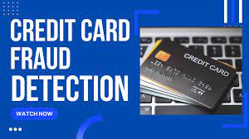

INTRODUCTION

* Credit card fraud detection is a vital security mechanism employed by financial institutions to protect cardholders and themselves from unauthorized or fraudulent transactions. By utilizing advanced algorithms, machine learning, and real-time monitoring, it identifies unusual patterns, anomalies, and behaviours associated with potential fraud. This proactive approach plays a crucial role in maintaining the integrity and trust of electronic payment systems.
* Credit cards are now the most preferred way for customers to transact either offline or online. There are a number of reasons, as illustrated below, due to which consumers are slowly shifting from debit card transactions to credit cards, especially in developing countries like India.
* There is an explosion of demand for new payment methods. With new payment methods, we have an extremely complex backend which makes fraud detection all the harder. We have nearly 1.8 billion Euros on average of fraudulent transactions detected in Europe every year.

DATASET LINK:([www.kaggle.com/data](http://www.kaggle.com/data))

***Machine Learning and AI Advancements:*** Over the years, the integration of machine learning and artificial intelligence has revolutionized fraud detection. These technologies continuously learn and adapt, improving their ability to detect even subtle signs of fraud. They analyse vast amounts of transaction data in real-time, making split-second decisions to block or flag potentially fraudulent transactions.

***Behavioural Analysis and Profiling:*** More sophisticated behavioural analysis techniques have been developed to create comprehensive profiles of cardholders. This involves considering historical transaction data, spending habits, and even factors like the time of day when a transaction occurs. Deviations from established behavioural patterns can trigger alerts.

***Geolocation and Device Verification:*** Mobile technology and geolocation services have become integral in verifying the authenticity of a transaction. Fraud detection systems can now cross-reference the location of the transaction with the cardholder's known location and even the device used, providing an extra layer of security.

***Multi-Factor Authentication:*** The adoption of multi-factor authentication, such as biometrics (e.g., fingerprint or facial recognition) and one-time passwords (OTP), enhances security by ensuring that the person making the transaction is indeed the legitimate cardholder.

***Big Data and Cloud Computing:*** The ability to process and analyse massive volumes of data is crucial. The use of big data analytics and cloud computing has enabled more efficient and scalable fraud detection systems. This allows for the rapid analysis of historical data and real-time monitoring of transactions across the globe.

***Collaborative Efforts and Information Sharing:*** Financial institutions increasingly collaborate and share data with one another. This collective intelligence helps identify emerging fraud trends and share information about known fraudulent entities, improving the industry's overall defences.

***Regulatory Compliance and Customer Protection:*** Stricter regulations and compliance standards have been put in place to ensure that financial institutions take the necessary steps to protect cardholders. Compliance with regulations like the Payment Card Industry Data Security Standard (PCI DSS) has become a central part of fraud prevention.

***Continuous Research and Development:*** The fight against fraud is ongoing, and fraudsters continually adapt. Therefore, financial institutions invest in research and development to stay ahead of emerging threats. They update and refine their fraud detection systems, making them more effective over time.

The development of credit card fraud detection is a dynamic and ever-evolving process as technology and the tactics of fraudsters continue to advance. Financial institutions and technology companies must remain at the forefront of innovation to ensure the security of electronic payment systems.

NECESSARY STEPS TO FOLLOW:

Start by importing libraries:

Pandas:

Pandas is essential for data manipulation and analysis, particularly for loading and handling datasets.

Program:

import pandas as pd

NumPy:

NumPy is used for numerical computations, and it complements Pandas for handling arrays and mathematical operations.

Program:

import NumPy as np

Scikit-Learn (sklearn):

Scikit-Learn provides tools for machine learning, including dataset splitting, preprocessing, and model evaluation. You'll import specific modules as needed for your analysis.

Program:

from sklearn. model selection import train_test_split

from sklearn. Preprocessing import StandardScaler # For data scaling (if needed)

Matplotlib and Seaborn:

These libraries are useful for data visualization, which is crucial for understanding your dataset.

Program:

import matplotlib.pyplot as plt

import seaborn as sns

LOAD THE DATASET:

To load a dataset for credit card fraud detection, We can use the Pandas library in Python. Here's how we can load a dataset from a CSV file, which is a common data format:

Program:

import pandas as pd

# Specify the file path to your dataset

file_path = 'your_dataset.csv'

# Use Pandas to read the CSV file into a DataFrame

df = pd.read_csv(file_path)

# Now, 'df' contains your dataset, and you can start working with it.

In the code above:

Import the Pandas library to work with data.

Replace 'your_dataset.csv' with the actual file path to our dataset. Make sure that the CSV file is in the same directory as our Python script, or provide the full path to the file if it's located elsewhere.

The pd.read_csv(file_path) function reads the CSV file and stores its contents in a Pandas DataFrame called df. This DataFrame is a two-dimensional table-like data structure that you can manipulate and analyze.

After loading the dataset into a Data Frame, we can perform various data analysis tasks, such as data exploration, preprocessing, and modelling, depending on your specific objectives in credit card fraud detection.

DATA EXPLORATION:

Data exploration is an iterative process, and the specific analyses. It's essential to gain a deep understanding of the data to make informed decisions on preprocessing and model selection for credit card fraud detection.

Basic Summary Statistics:

Use Pandas to obtain summary statistics of the dataset, which can give a quick overview of the data, including counts, means, standard deviations, and percentiles.

Program:

print(df.describe())

Data Visualization:

Create visualizations to explore the data. Common types of plots include histograms, box plots, and scatter plots. We can use libraries like Matplotlib and Seaborn for this purpose.

Program:

import matplotlib.pyplot as plt

import seaborn as sns

# Example: Histogram of transaction amounts

plt.figure(figsize=(8, 5))

sns.histplot(df['Amount'], bins=50, kde=True)

plt.title('Transaction Amount Distribution')

plt.xlabel('Amount')

plt.ylabel('Count')

plt.show()

Class Distribution:

In credit card fraud detection, it's essential to understand the class distribution, i.e., the number of fraudulent (Class 1) and non-fraudulent (Class 0) transactions. An imbalanced dataset might require special handling during modeling.

Program:

class_distribution = df['Class'].value_counts()

print(class_distribution)

Correlation Analysis:

Examine correlations between features. This can help identify relationships between variables and reveal potential patterns or anomalies.

Program:

correlation_matrix = df.corr()

plt.figure(figsize=(10, 8))

sns.heatmap(correlation_matrix, annot=False, cmap='coolwarm')

plt.title('Correlation Matrix')

plt.show()

Outlier Detection:

Identify and investigate potential outliers, which could be indicative of fraudulent activities.

Program:

from scipy import stats

z_scores = stats.zscore(df['Amount'])

outliers = df[(z_scores > 3) | (z_scores < -3)]

Feature Importance:

To use machine learning models, analyse feature importance to understand which attributes play a significant role in distinguishing between fraudulent and non-fraudulent transactions.

Program:

from sklearn.ensemble import RandomForestClassifier

# Fit a model to assess feature importance

model = RandomForestClassifier()

model.fit(X, y)

feature_importance = model.feature_importances_

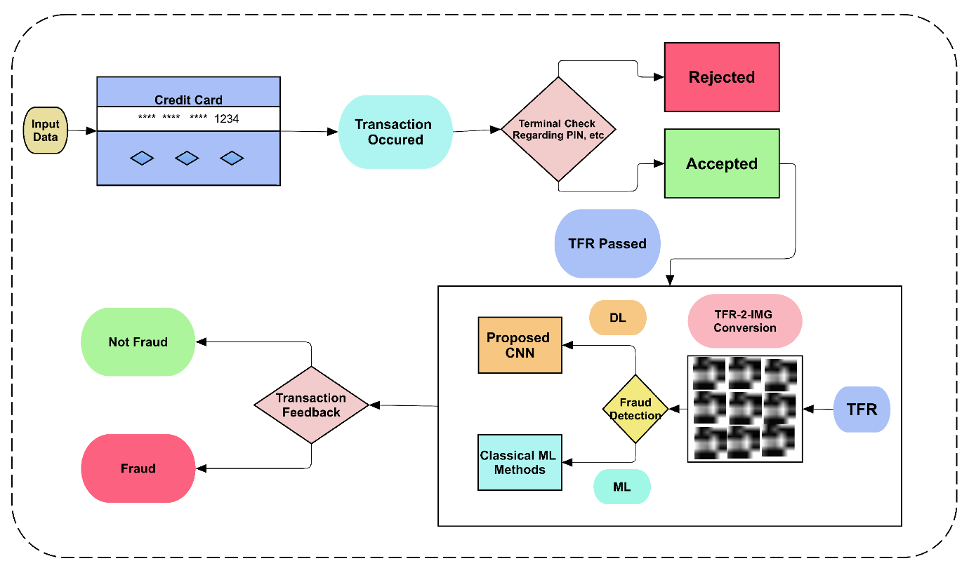

CONCLUSION

The development of credit card fraud detection is an ongoing and dynamic process driven by the need to protect financial institutions and cardholders from unauthorized or fraudulent transactions. The key takeaways from the development of credit card fraud detection include:

***Advanced Technology Integration:*** The integration of advanced technologies like machine learning, artificial intelligence, and big data analytics has revolutionized fraud detection systems, allowing them to adapt and evolve with the changing landscape of fraud.

***Behavioural Analysis and Profiling:*** The ability to create comprehensive profiles of cardholders and analyse their behavioural patterns is instrumental in identifying deviations and anomalies indicative of fraud.

***Data Sharing and Collaboration:*** Collaboration and data sharing among financial institutions play a vital role in identifying emerging fraud trends and improving the collective defences of the industry.

***Regulatory Compliance and Customer Protection:*** Stricter regulations and compliance standards ensure that financial institutions take the necessary steps to protect cardholders and maintain the integrity of the financial system.

***Continuous Research and Development:*** The fight against fraud is ongoing, and financial institutions invest in research and development to stay ahead of emerging threats. Regular updates and refinements to fraud detection.

In the conclusion we have loaded the dataset and completed with foundational steps then our dataset is now primed for the subsequent stages of fraud detection in credit card.